August 15, 2020

Walker Bag Instructions

- Inside of the walker bag with the single large pocket and cell phone holder:

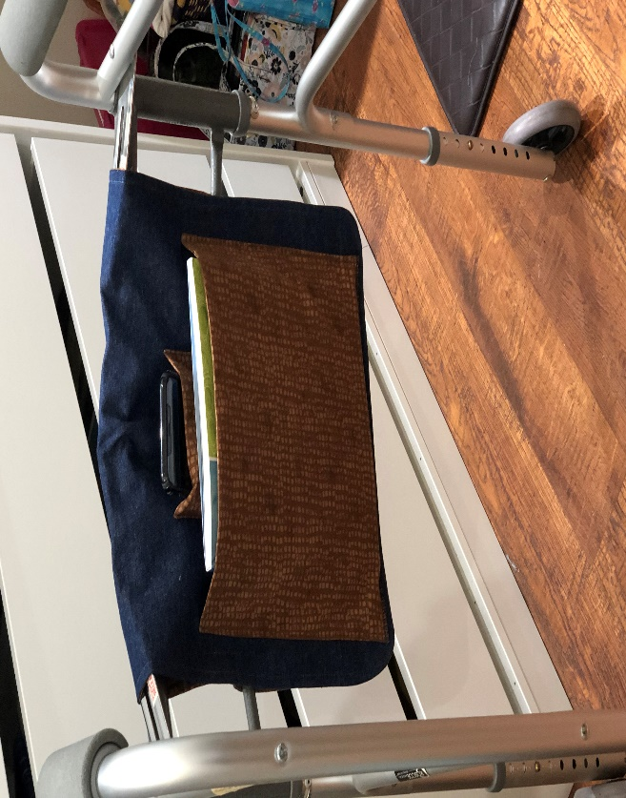

2. Outside (Front) of the wheelchair bag with the large pockets
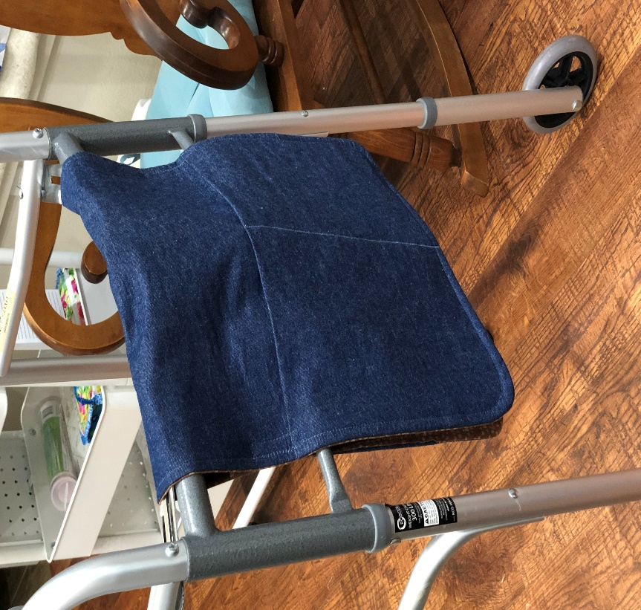

The walker bag will have the following pieces:

Velcro - Two Sets of Sew-On Velcro – 2” long x about 1/2” wide
Piece A - Outside – One piece measuring 30.5” x 15.5”
-Iron-on Interfacing or fusible fleece for this piece
Piece B -Inside – One piece measuring 30.5” x 15.5”
Piece C -Front Pocket – One piece measuring 20 x 15.5” (fold 20” in half to equal 10” deep pocket for the front. Stitch this piece to piece A and stitch a straight seam down the middle of this piece to make 2 pockets.
Piece D -Cell Phone Pocket – Make a patch pocket measuring about a finished 5” x 6”
Piece E -Large Pocket for the inside of the walker – an 11 x 12” patch pocket to be placed on the opposite end of walker bag from C Front Pocket above. The cell phone pocket will be sewn on first inside but just above this pocket and then this pocket sewn on. You may want to curve the bottom corners of this piece to make it easier to sew on.

- Iron Interfacing onto the A Outside piece.
- Layer pieces A, B (with piece C attached).
- To curve the edges of each end, use a glass or small plate to draw a curve on each edge and cut around the curve.
- Sew a 1/4” seam around the outside of the piece, leaving a 4” opening to turn the piece.
- Turn it right side out, press it flat and stitch a 1/4” top stitch around being sure to catch the opening that was left open for turning.
- Now sew on first the D - cell phone pocket in the center of the opposite side of the bag from the first double pocket. It should be about 12” from the bottom of the bag.
- Sew E – Large Pocket centered about an inch below the cell phone pocket
- Sew the Velcro on both sides of the inside of the bag, lengthwise, with the top of the piece 11” from the bottom of each end of the bag.

Thank you for blessing someone with this walker bag! It will make their life much easier.

Trinity Valley Quilters’ Guild

